select all nr_depto from colaborador_tarde order by nr_depto  
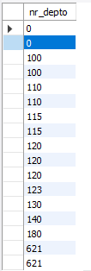

select all primeiro_nome, ultimo_nome, salario, salario/12 from colaborador_tarde order by primeiro_nome

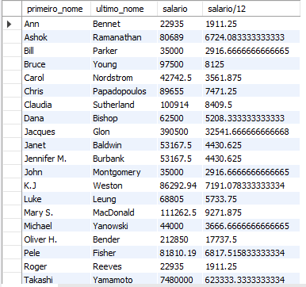

select * from colaborador_tarde where Nr_Depto = 120

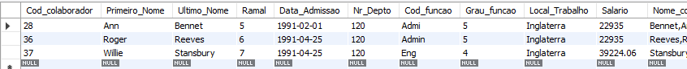

select * from colaborador_tarde where (salario >= 80000.00) and (salario <= 90000.00)

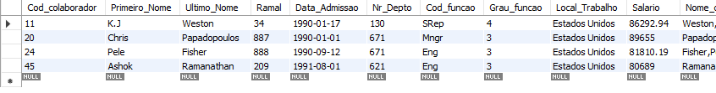

select * from colaborador_tarde where salario between 80000.00 and 90000.00

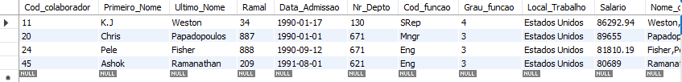

select ultimo_nome,primeiro_nome,local_trabalho from colaborador_tarde where Local_Trabalho in ('canada','Inglaterra')

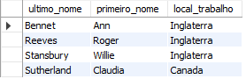

select primeiro_nome,salario,data_admissao from colaborador_tarde where Data_Admissao between '1991/01/01' and '1991/12/31' order by data_admissao

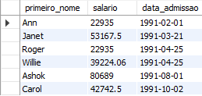

select salario from colaborador_tarde where nr_depto = 120

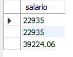

select sum(salario) as 'total do salario do departamento' from colaborador_tarde where nr_depto = 120

